OVERALL DESCRIPTION OF THE SET OF 15 JOINED KHIPUS (RT-16905) STUDIED IN MNAAHP

Date: September 2023
Researchers: Andrés Chirinos (UNED), Iván Ghezzi (UDEP), Alcides Álvarez (IDARQ)

- DIAGRAM
Figure 1 shows the way this description will follow. The set of linked khipus or “Khipus Enlazados” is sewn to a frame, made by the museum curators in recent years. From the edge in the left to the right and from the upper to the below part it occupies 139 cm x 130 cm. Then, we consider a line or axe in the middle of this set of linked khipus, starting at the left, where the primary cord of Khipu11 starts, then following hubs C, A, B, and ending where the primary cord of Khipu14 ends. It has 84 cm, and the partial measurements are:

Starting Edge & Hubs | Start position (cm) | Hubs at ending edge of the line or axe | End position (cm) | Spacing (cm)
Beginning of Primary Cord of Khipu 11 | 0 | Hub C | 15.5 | 14.5
Hub C | 15.5 | Hub A | 30 | 14
Hub A | 30 | Hub B | 44 | 40
Hub B | 44 | End of Primary Cord of Khipu 14 | 84 | End

This line divides half part of the set, with the Khipus 11, 12, 13 and 14 (from left to right) in the below part. The rest of the khipus, i.e., 10, 01, 15, 02, 03, 04, 05, 06, 07, 08 and 09 (from left to right) are in the upper part. The exception is the Khipu11 which has two groups of their pendants (groups 8 and 9) in the upper part, between khipus 10 and 01. Khipu15, which is in the upper part, has a special position in the middle of the two groups that are part of Khipu01.

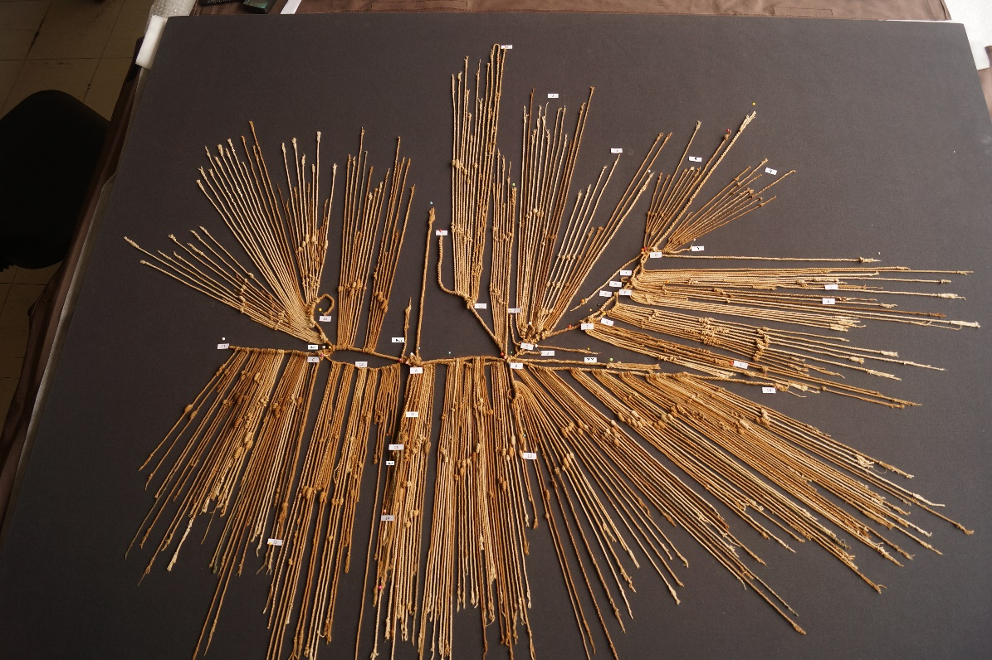

Figure 1

- HUBS AND SPECIAL ZONES
The hubs or special places:

Hub A. It is the place where are attached the following khipus: 11, 12, 13, 14 and the bundle H. It has a diameter of 2 cm.

Hub B. It is to the right of Hub A. It is the place where are attached khipus 01, 13 and 14. It has 1.5 cm of diameter.

Hub C. It is at the left of Hub A. It is the place where are attached khipus 10, 11 and 12. It has 2 cm of diameter.

These three Hubs and the Bundle H connects all the khipus that are in the below part of the set and two more khipus from the upper part, khipus 10 and 01. The next four hubs D, E, F, G are connecting khipus 02, 03, 04, 05, 06, 07, 08 and 09 with the primary cords of Khipu01 and Khipu04.

Hub D, is at 2 cm from Hub C. It is the place where Khipus 02 and 03 are tied with the primary cord of Khipu01. It has a tubular form: 3.5 long and 1 cm diameter.

Hub E is the next hub which connects Khipu04 with the primary cord of Khipu01. Diameter 2 cm.

“Zone F” runs along the primary cord of Khipu04 from Hub E until Hub G, along 10 cm. In this zone the Khipus 05, 06 and 07 are attached.

Hub G is where Khipus 08 and 09 are attached to the primary cord of Khipu04. It has a tubular form, 2 cm length and diameter 1.5 cm.

Bundle H. It has a tubular form, 35 cm length and a diameter of 2 cm. Here there are tied 7 cords. Two of these cords are the final parts of primary cords of Khipu11 and Khipu12, a third cord is the Tie Cord02 (explain below). Finally, there are four cords which are pendants of Khipu11. Besides all these seven cords are tied with the Tie Cord04 (explain below).

- TIED CORDS
Tie Cord01. It is used to tie Hub B. Thickness 4.2 mm. From the beginning to Hub B, 31 cm and from Hub B to the end, 23 cm. Looks like a primary cord.

Tie Cord02. It is used to tie Hub A. Thickness 3 mm. From the beginning to Hub A, 26 cm and from Hub A to the end, 11 cm. Looks like a primary cord.

Tie Cord03. It is used to tie Hub C. Thickness 1.8 mm. Its starting point in Hub C is not visible, from Hub C to the end, 32 cm. It does not seem to be a primary cord.

Tie Cord04. It is used to tie Bundle H. Thickness 1.4 mm. From where this cord is tied hangs in two parts, each of 14 cm. In one of this cord parts are two knot clusters. First knot is at 3 cm of the tied part, it is a long knot 3L, S direction, d axe orientation, second cluster is at 8 cm, a single knot 1S, Z direction.

In Table 01 (below) is the information of the measuring and other characteristic of these Tie Cords.

Table 01: Tie Cords description

 | TIED CORD_LENGTH (cm) | FIBER | STRUCTURE | TERMINATION | BEGINNING | TWIST (FINAL) | COLOR | NOTES
Tie Cord01 | 54 | CN | P | K | R | S | W-W-MB | It is used to tie Hub B. Thickness 4.2 mm. From the beginning to Hub B, 31 cm and from Hub B to the end, 23 cm. Looks like a primary cord.
Tie Cord02 | 37 | CN | P | R | R | S | W:MB | It is used to tie Hub A. Thickness 3 mm. From the beginning to Hub A, 26 cm and from Hub A to the end, 11 cm. Looks like a primary cord.
Tie Cord03 | 32 | CN | P | K | U | S | W | It is used to tie Hub C. Thickness 1.8 mm. Its starting point in Hub C is not visible, from Hub C to the end, 32 cm. Because its thickness it does not seems to be a primary cord.
Tie Cord04 | 28 | CN | P | K | R | S | GG | It is used to tie Bundle H. Thickness 1.4 mm. From where this cord is tied hangs in two parts, each of 14 cm. In one of this cord parts are two knot clusters. First knot is at 3 cm of the tied part one long knot 3L, S direction, d axe orientation, second cluster is at 8 cm, has a single knot 1S, Z direction.

